Mini Assignment: Agentic Invoice Processing Workflow
Design and implement a simple agentic AI workflow that processes invoices and automatically extracts, validates, and stores required information using an LLM and tools.
- Students will be given 4 invoice files
- Their system must process each invoice end-to-end with minimal hard-coding.

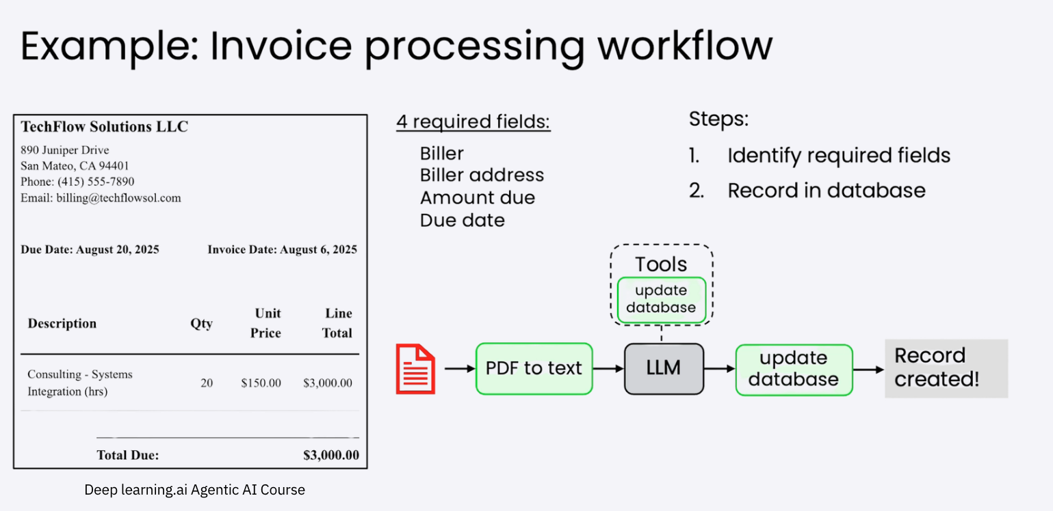

A. Input
- 4 invoice documents (PDF or image format)
Each invoice contains (at minimum):
- Biller name
- Biller address
- Invoice date
- Due date
- Line items
- Total amount due

B. Required Fields (Must Be Extracted)
Your system must correctly identify and extract the following 4 required fields:
- Biller
- Biller address
- Total
- Due date
If any required field is missing, the system must flag the invoice as incomplete.

C. Required Tasks
Students must implement an agentic workflow that performs the following tasks:

Task 1: Document Ingestion
- Accept an invoice as input (PDF or image).
- Convert it into text using:
  - PDF-to-text, OCR, or equivalent.

Task 2: Information Extraction (LLM-Driven)
- Use an LLM to:
  - Identify the required fields.
  - Extract their values.
- The LLM must return structured output (e.g., JSON).

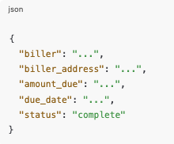

Task 3: Validation Agent
- Implement a validation step (agent or function) that:
  - Checks if all required fields exist.
  - Validates basic formats (date, amount).
- If validation fails:
  - Mark the invoice as "incomplete"
  - Include a reason.

Task 4: Tool Use (Database Update)
- Implement a tool that:
  - Writes valid invoices into a database (SQL DB).
- The LLM must not write directly to the database.
- The LLM should decide when to call the tool.

D. Constraints
- No manual field mapping per invoice.
- No invoice-specific hard-coding.
- The same workflow must work for all 5 invoices.

